JETBLUE AIRWAYS CORPORATION: GETTING OVER THE “BLUES”?*
In 2017 JetBlue faced challenges that included rising fuel prices, troubling technical disruptions, and declining quality of the flying experience. Since the beginning of 2016, JetBlue had enjoyed low fuel prices that helped increase their earnings about 18 percent during the second quarter of 2016,¹ but the company experienced technical issues that caused booking problems and resulted in delays, as well as bad publicity. In order to cope with the likelihood of a rise in future fuel prices, JetBlue undertook massive cost reductions by investing in cabin restyling, for instance, adding more seats to JetBlue’s A320 airplanes. However, the shrinking legroom that accompanied the cabin restyling was despised by passengers, which posed a problem for an airline that had once offered customers a captivating (as opposed to a captive) flying experience.
To meet the challenges, new CEO Robin Hayes orchestrated various initiatives that the company planned to take through 2017. Those initiatives included wider fare options, enhanced Mint services, cabin restyling, new lines of JetBlue credit cards, and partnerships with other airlines.²
The founding CEO of JetBlue, David Neeleman, had been ousted by the board of directors after a notorious event when an ice storm severely disrupted the airline’s operations.³ In 2007, Dave Barger, an employee since the inception of JetBlue in 1998, became the second CEO of the company. Ultimately Barger was pressured to step down amid constantly depressed stock prices. In February 2015, Robin Hayes took charge of the company as its third chief executive. Hayes was the executive vice president of British Airways for the Americas before joining JetBlue in August 2008. Having worked for about 25 years and having extensive experience in the airline industry, Hayes was considered an optimal choice to become the third chief executive of JetBlue.
In promoting Robin Hayes to be the airline’s new CEO, JetBlue’s board signaled its readiness to focus on investor-friendly changes. With news of his selection, the share price immediately soared by 5 percent. But JetBlue loyalists who loved the company for its customers-first policies were getting more and more uncomfortable (see Exhibit 1).⁴ Would JetBlue soar into clearer skies, or would it sink into the “blues” again?
EXHIBIT 1 JetBlue’s Stock Performance versus S&P 500

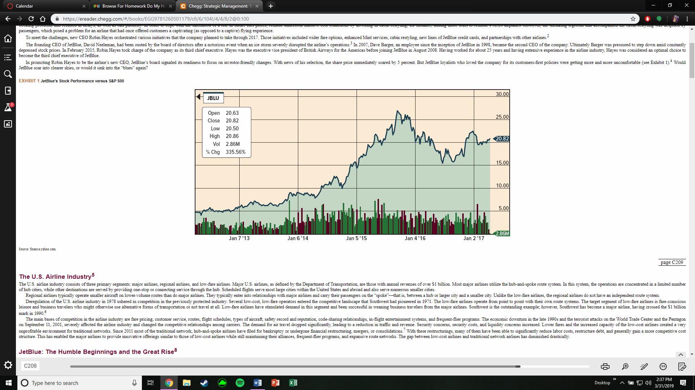

Source: finance.yahoo.com.
page C209

The U.S. Airline Industry⁵
The U.S. airline industry consists of three primary segments: major airlines, regional airlines, and low-fare airlines. Major U.S. airlines, as defined by the Department of Transportation, are those with annual revenues of over $1 billion. Most major airlines utilize the hub-and-spoke route system. In this system, the operations are concentrated in a limited number of hub cities, while other destinations are served by providing one-stop or connecting service through the hub. Scheduled flights serve most large cities within the United States and abroad and also serve numerous smaller cities.
Regional airlines typically operate smaller aircraft on lower-volume routes than do major airlines. They typically enter into relationships with major airlines and carry their passengers on the “spoke”—that is, between a hub or larger city and a smaller city. Unlike the low-fare airlines, the regional airlines do not have an independent route system.
Deregulation of the U.S. airline industry in 1978 ushered in competition in the previously protected industry. Several low-cost, low-fare operators entered the competitive landscape that Southwest had pioneered in 1971. The low-fare airlines operate from point to point with their own route systems. The target segment of low-fare airlines is fare-conscious leisure and business travelers who might otherwise use alternative forms of transportation or not travel at all. Low-fare airlines have stimulated demand in this segment and been successful in weaning business travelers from the major airlines. Southwest is the outstanding example; however, Southwest has become a major airline, having crossed the $1 billion mark in 1990.⁶
The main bases of competition in the airline industry are fare pricing, customer service, routes, flight schedules, types of aircraft, safety record and reputation, code-sharing relationships, in-flight entertainment systems, and frequent-flier programs. The economic downturn in the late 1990s and the terrorist attacks on the World Trade Center and the Pentagon on September 11, 2001, severely affected the airline industry and changed the competitive relationships among carriers. The demand for air travel dropped significantly, leading to a reduction in traffic and revenue. Security concerns, security costs, and liquidity concerns increased. Lower fares and the increased capacity of the low-cost airlines created a very unprofitable environment for traditional networks. Since 2011 most of the traditional network, hub-and-spoke airlines have filed for bankruptcy or undergone financial restructuring, mergers, or consolidations.⁷ With these restructurings, many of them have been able to significantly reduce labor costs, restructure debt, and generally gain a more competitive cost structure. This has enabled the major airlines to provide innovative offerings similar to those of low-cost airlines while still maintaining their alliances, frequent-flier programs, and expansive route networks. The gap between low-cost airlines and traditional network airlines has diminished drastically.

JetBlue: The Humble Beginnings and the Great Rise⁸
Born in São Paulo, Brazil, and brought up in Salt Lake City, David Neeleman, along with June Morris, launched Utahbased Morris Air, a charter operation, in 1984. Morris Air was closely modeled after Southwest Airlines, the legendary discount airline. Neeleman considered Herb Kelleher, Southwest’s founder, his idol.
While following the Southwest model, Neeleman brought his own innovations into the business. He pioneered the use of at-home reservation agents, routing calls to agents’ homes to save money on office rent and infrastructure expense. He also developed the first electronic ticketing system in the airline industry. Impressed by Morris’s low costs and high revenue, Southwest bought the company for $129 million in 1992. Neeleman became an executive vice president of Southwest. However, he could not adjust to Southwest’s pace of doing things. By 1994, he was at odds with top executives, and he left after signing a five-year noncompete agreement.
After the noncompete agreement with Southwest Airlines ended in 1999, Neeleman launched his own airline. He raised about $130 million of capital in two weeks.⁹ With such strong support from venture capitalists, JetBlue began as the highest-funded start-up airline in U.S. aviation history. JetBlue commenced operations in August 2000, with John F. Kennedy International Airport (JFK) as its primary base of operations. In 2001, JetBlue extended its operations to the West Coast with its base at Long Beach Municipal Airport, which served the Los Angeles area. In 2002, the company went public and was listed on NASDAQ as JBLU. JetBlue’s stock offering was one of the hottest IPOs of the year.¹⁰
JetBlue had been established with the goal of being a leading low-fare passenger airline that offered customers a differentiated product and high-quality customer service on point-to-point routes. JetBlue had a geographically diversified flight schedule that included both short-haul and long-haul routes. The mission of the company, according to Neeleman, was “to bring humanity back to air travel.” To stimulate demand, the airline focused on underserved markets and large metropolitan areas that had high average fares.
JetBlue was committed to keeping its costs low. To achieve this objective, the company originally operated a single-type aircraft fleet comprising Airbus A320 planes as opposed to the more popular but costly Boeing 737. The A320s had 162 seats, compared to 132 seats in the Boeing 737. According to JetBlue, the A320 was less expensive to maintain and more fuel-efficient. Since all of JetBlue’s planes were new, the maintenance costs were also lower. In addition, the single type of aircraft kept training costs low and increased personnel utilization. JetBlue was the first to introduce the “paperless cockpit,” in which pilots, equipped with laptops, had ready access to flight manuals that were constantly updated at headquarters. As a result, pilots could quickly calculate the weight, balance, and takeoff performance of the aircraft instead of having to download and print the manuals to make the calculations. The paperless cockpit ensured faster takeoffs by reducing paperwork and thus helped the airline achieve quicker turnarounds and higher aircraft utilization.¹¹ No meals were served on the planes, and pilots even had to be ready, if need be, to do cleanup work on the plane to minimize the time the aircraft was on the ground. Turnaround time was also reduced by the airline’s choice of less congested airports.¹² Innovation was everywhere. For example, there were no paper tickets to lose and no mileage statements to mail to frequent fliers.
page C210
With friendly, customer service–oriented employees; new aircraft; roomy leather seats with 36 channels of free LiveTV, 100 channels of free XM satellite radio, and movie channel offerings from FOXInflight; and more legroom (one row of seats was removed to create additional space), JetBlue promised its customers a distinctive flying experience, the “JetBlue experience.” With virtually no incidents of passengers being denied boarding; high completion factors (99.6 percent as compared to 98.3 percent at other major airlines); the lowest incidence of delayed, mishandled, or lost bags; and the third-lowest number of customer complaints, the company was indeed setting standards for low-cost operations in the industry. JetBlue was voted the best domestic airline in the Conde Nast Traveler’s Readers’ Choice Awards for five consecutive years. Readers of Travel + Leisure magazine also rated it the World’s Best Domestic Airline in 2006. In addition, it earned the Passenger Service Award from Air Transport World.¹³

Hitting Bumpy Air
Nevertheless, high fuel prices, the competitive pricing environment, and other cost increases made it increasingly difficult to keep JetBlue growing and profitable. The airline suffered its first-ever losses after its IPO in 2005. It posted net losses of $20 million and $1 million for 2005 and 2006, respectively.¹⁴
The ice storm on Valentine’s Day 2007 that cost Neeleman his job was a nightmare in JetBlue’s hitherto high-flying history for more than one reason. Not only did the event destroy JetBlue’s reputation for customer friendliness, but it also exposed critical weaknesses in the systems that had kept the airline’s operations going. The airline’s reputation hit rock bottom. To limit the damage, JetBlue announced huge compensations to customers—refunds and future flights—which were to cost the airline about $30 million. Neeleman quickly followed up with a new Customer Bill of Rights. The Customer Bill of Rights outlined self-imposed penalties for JetBlue and major rewards for its passengers if the airline experienced operational problems and could not adjust to weather-related cancelations within a “reasonable” amount of time. All these announcements and even a public apology could not restore things to normalcy. Neeleman was pushed out as CEO on May 10, 2007. Dave Barger, the president, assumed the position of chief executive officer.

Restoring JetBlue’s Luster?
Under the second CEO, Dave Barger, JetBlue added several new services and embarked on capacity expansion to give the airline a new boost. In July 2007, it became the first U.S. carrier to let passengers send free email and text messages from wireless handheld devices, a technology developed through its LiveTV LLC subsidiary.¹⁵ Later, in September 2007, it expanded to smaller cities that did not have sufficient demand for the larger planes flown by Southwest, Virgin America, and Skybus Airlines. It also introduced Embraer jets to its fleet.¹⁶
In 2007, JetBlue had its first full-year profit in three years as an increase in traffic and operational improvements helped compensate for skyrocketing fuel costs. However, as a result of global financial turmoil and skyrocketing fuel prices, JetBlue’s profits tanked again in 2008, and the company reported a net loss of $85 million.¹⁷ Nevertheless, the company returned to profitability in 2009. In April 2010, JetBlue successfully completed the International Air Transport Association’s (IATA’s) Operational Safety Audit (IOSA) and achieved IOSA registration, meeting the same highest industry benchmarks as other world-class airlines.¹⁸
Dave Barger was known for “being overly concerned” with customer service and comfort.¹⁹ During Barger’s tenure, JetBlue earned tributes for its customer service. However, its low-fare business model was being threatened as its costs kept going up. In April 2014, its pilots, long nonunion, voted to join the Air Line Pilots Association.²⁰ In the wintertime the airline was again racked by weather-driven flight cancelations. JetBlue’s stock under Barger’s leadership lagged behind big legacy carriers Delta Air Lines and fellow discounter Southwest Airlines. The shares were up just 9 percent since Barger became CEO.²¹ In the same period, Southwest’s shares gained more than 140 percent and the overall Bloomberg U.S. Airline index gained 49 percent.²²

Current Leadership
The new CEO, Robin Hayes, unveiled a new pricing model that included four different pricing categories (see Exhibit 2). Under the new fare structure, passengers were able to choose which features they did or didn’t want included in the ticket price. At the low end of the pricing spectrum, tickets did not include a checked bag. Passengers who paid higher fares were entitled to checked bags (one bag at Blue-Plus level, two at the Blue-Flex and Mint levels) and got bonus loyalty points. At the high end of the pricing, the “Even More” seating option offered extra legroom (38 inches of pitch), expedited security clearance, and priority access to overhead bin space. With this fare structure, seats were subject to variable pricing not only by flight but also by their specific position in the aircraft. Hayes said that the airline was committed to delivering “the best travel experience for our customers. . . . JetBlue’s core mission to Inspire Humanity and its differentiated model of serving underserved customers remain unchanged.”²³
The substantial challenge regarding a trade-off between travel experience and profit margins remained. The question was, would JetBlue be able to hold onto its core mission and still be able to make its stakeholders happy? Investors wondered if JetBlue really had a strong and clear strategic position and coherent business model to support it. Were too many complexities being introduced into its simple model of success?

EXHIBIT 2
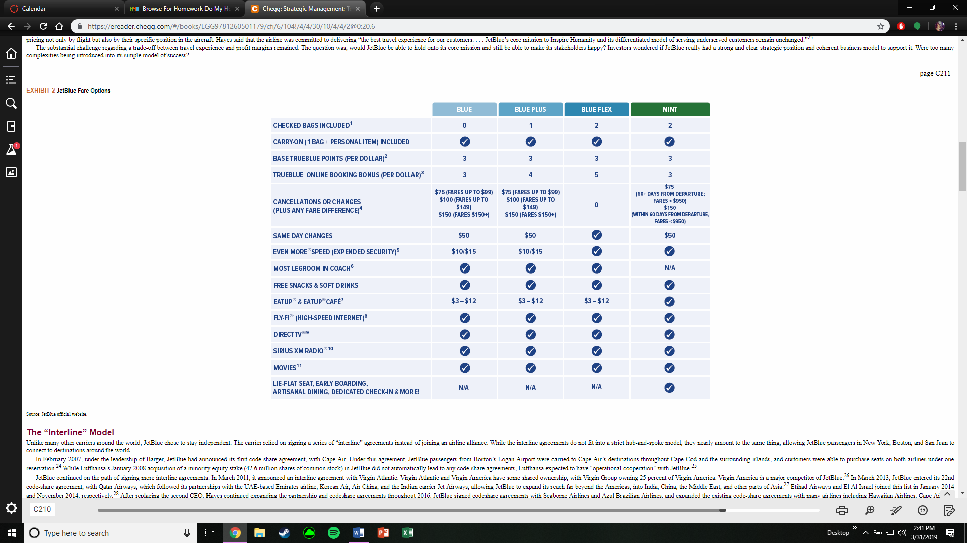

The “Interline” Model
Unlike many other carriers around the world, JetBlue chose to stay independent. The carrier relied on signing a series of “interline” agreements instead of joining an airline alliance. While the interline agreements do not fit into a strict hub-and-spoke model, they nearly amount to the same thing, allowing JetBlue passengers in New York, Boston, and San Juan to connect to destinations around the world.
In February 2007, under the leadership of Barger, JetBlue had announced its first code-share agreement, with Cape Air. Under this agreement, JetBlue passengers from Boston’s Logan Airport were carried to Cape Air’s destinations throughout Cape Cod and the surrounding islands, and customers were able to purchase seats on both airlines under one reservation.²⁴ While Lufthansa’s January 2008 acquisition of a minority equity stake (42.6 million shares of common stock) in JetBlue did not automatically lead to any code-share agreements, Lufthansa expected to have “operational cooperation” with JetBlue.²⁵
JetBlue continued on the path of signing more interline agreements. In March 2011, it announced an interline agreement with Virgin Atlantic. Virgin Atlantic and Virgin America have some shared ownership, with Virgin Group owning 25 percent of Virgin America. Virgin America is a major competitor of JetBlue.²⁶ In March 2013, JetBlue entered its 22nd code-share agreement, with Qatar Airways, which followed its partnerships with the UAE-based Emirates airline, Korean Air, Air China, and the Indian carrier Jet Airways, allowing JetBlue to expand its reach far beyond the Americas, into India, China, the Middle East, and other parts of Asia.²⁷ Etihad Airways and El Al Israel joined this list in January 2014 and November 2014, respectively.²⁸ After replacing the second CEO, Hayes continued expanding the partnership and codeshare agreements throughout 2016. JetBlue signed codeshare agreements with Seaborne Airlines and Azul Brazilian Airlines, and expanded the existing code-share agreements with many airlines including Hawaiian Airlines, Cape Air, and Icelandair Airlines, among others. In response to growing competition, JetBlue’s expansion of codeshare agreements marked a departure from the company’s initial strategy to stay independent.

More Goodies for Customers
Over the years, JetBlue has constantly tried to maintain its customer-first attitude. It introduced its “Go Places” application on Facebook, which rewarded customers with TrueBlue points and special discounts so they could earn free trips faster. The “Even More” suite of products and services—including early boarding, early access, expedited security experience, and extra legroom—has been an interesting innovation. JetBlue has added more benefits for its frequent fliers through its “TrueBlue Mosaic” loyalty program. The services include a free second checked bag, a dedicated 24-hour customer service line, and bonus points, among many other offers.²⁹
page C212
JetBlue became the first Federal Aviation Administration– certified carrier in the U.S. to utilize the new satellite-based Special Required Navigation Performance Authorization Required (RNP AR) approaches at its home base at New York’s JFK airport. These unique procedures have resulted in stabilized approach paths, shorter flight times, and reduced noise levels and greenhouse gas emissions, and they have increased fuel savings by as much as 18 gallons per flight.³⁰ In 2017, with an operating margin of 19.65 percent, JetBlue was doing better than in previous years as compared to its close competitors (see Exhibit 3).
Nevertheless, in October 2013, amid cost cutting, JetBlue had announced a fleet modernization program that included deferral of 24 Embraer aircraft from 2014–2018 to 2020–2022 so that capital expenditures could be reduced over the near term (see Exhibits 4 and 5). It also converted 18 orders with Airbus from A320 to A321 aircraft. It said its future focus would be on adding aircraft with more fuel-efficient engines. JetBlue also shrank legroom, adding 15 more seats to its Airbus A320 planes.³¹

Reinventing JetBlue
Under Hayes’s leadership, JetBlue has gone through many changes to “reinvent” the company, including new interline agreements, new codesharing agreements, various strategic partnerships with other commercial airlines, launch of JetBlue credit cards, and creation of JetBlue Technology Ventures LLC to invest in emerging technologies related to the travel and hospitality industry.³² However, the company has also faced challenges, including technical problems when customers were unable to book or modify their existing reservations amid an outage in computer systems.³³ In May 2016, eight passengers were injured amid heavy turbulence on a JetBlue flight from San Juan to Orlando.³⁴ In August 2016, heavy turbulence on another JetBlue flight from Boston to Sacramento put 24 people in the hospital, including two crew members and 22 passengers.³⁵
EXHIBIT 3 Operating Margins of Major U.S. Airlines
